**SQL revision practice ----12-01-2024**

**Create table name as Student using a following field**

|  |  |
| --- | --- |
| **Column Name** | **Data Type** |
| Id | Int(5) |
| Name | Varchar(100) |
| Email | Varchar(100) |
| Contact | Varchar(100) |
| salary | Int(5) |

Ans:



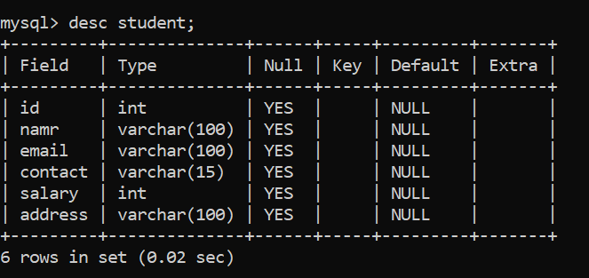

**After creating a table performs following DDL operations on it.**

**Perform Alter Statement**

**Q2. Add New Column name as address with varchar (200) data type in student table using alter statement**

**Ans:**

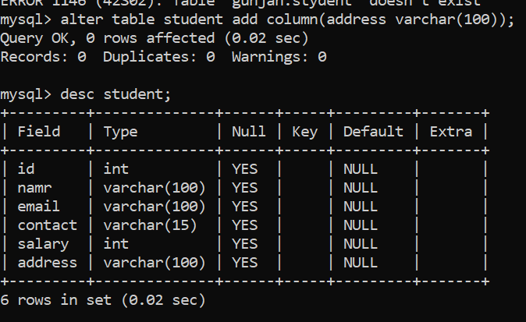

**Q3. Add New 3 columns at a time in Student table name as designation with varchar(200) data type , adharno varchar(200), panno varchar(200) using alter add option**

Ans:



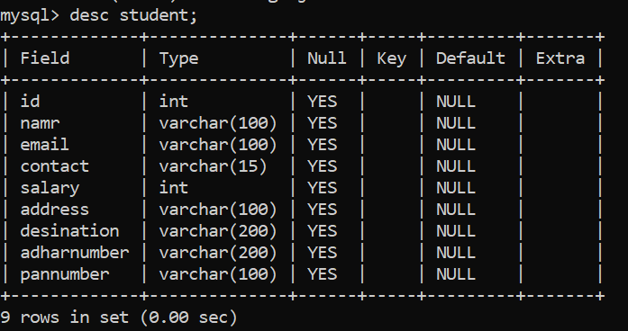

**Q4. You have to drop column name adharno from student table using alter drop statement**

Ans: 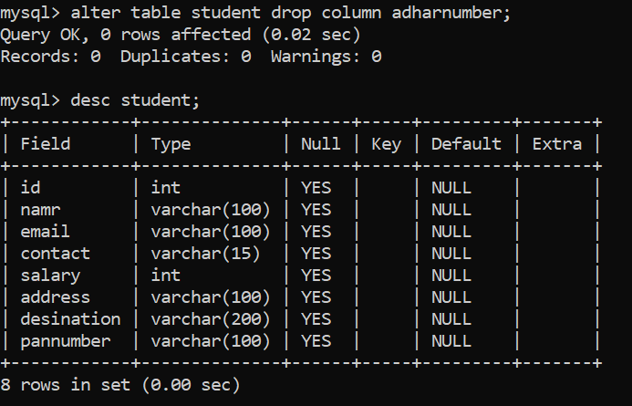

**Q5. You have to rename column salary to sal from student table using alter rename option**

**Ans:** 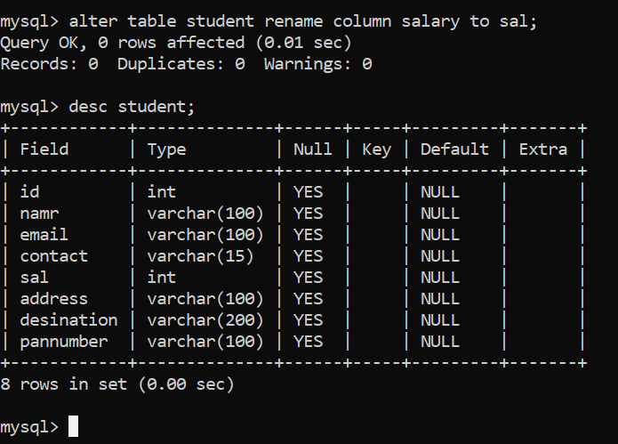

**Q6. Write SQL query to insert only id, name and contact in employee table?**

**Ans:**

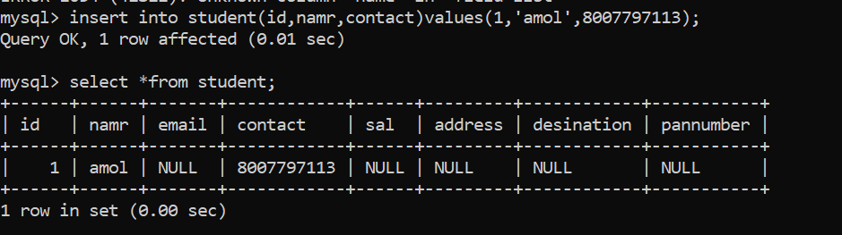

**Q7. Write SQL Query to display all employee record using all columns values?**

**Ans:**

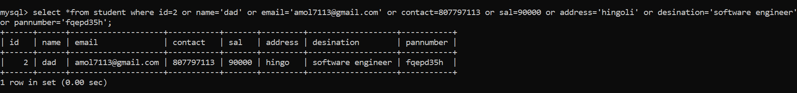

**Q8 . Write SQL Query to delete employee whose id is 1 and name is ram**

**Ans:** 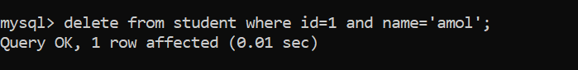

**Q9. Write SQL Query to delete employee whose id is 1 or name is shyam**

**Ans:** 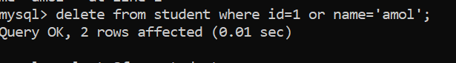

**Q10. Write SQL Query to display all employee whose name is ram and salary is not 10000 ?**

**Ans:** 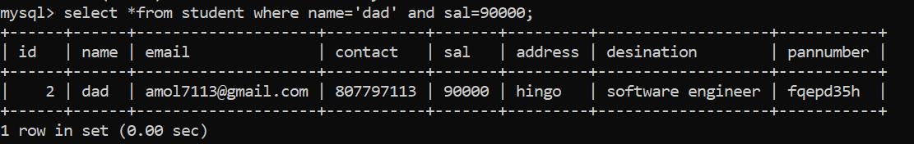

**Q11. Write SQL Query to display all employee whose salary is 10000 and email is** [**ram@gmail.com**](mailto:ram@gmail.com)

**Ans:** 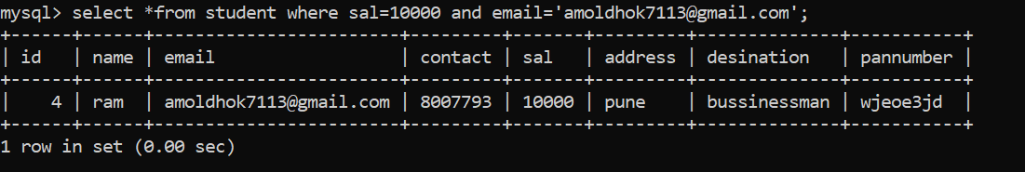

**Q12. Write SQL Query to display all employees whose salary is less than 10000 and name is ram?**

**Ans:** 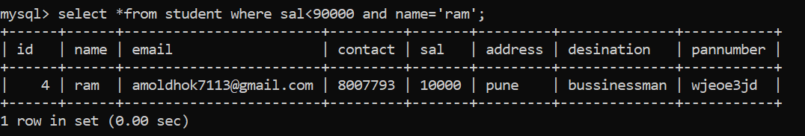

**Q13. Display employee records whose salary between 10000 and 60000?**

**Ans:** 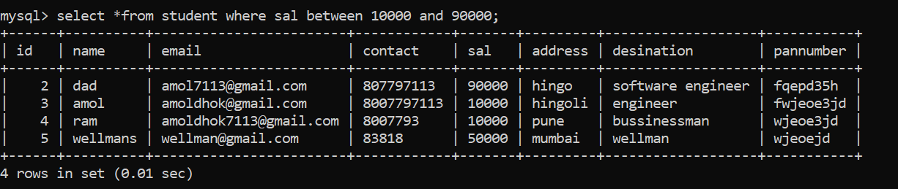

**Q14. Display employee records whose salary is 10000,20000,30000 and name is not ramesh?**

**Ans:**

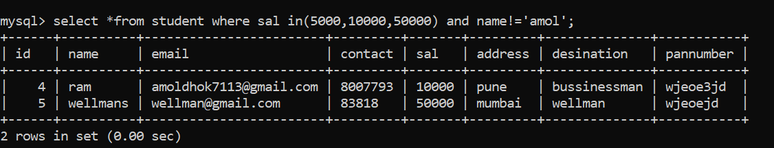

**Q15. Display employee records whose name is ram, shyam, ganesh?**

**Ans:**

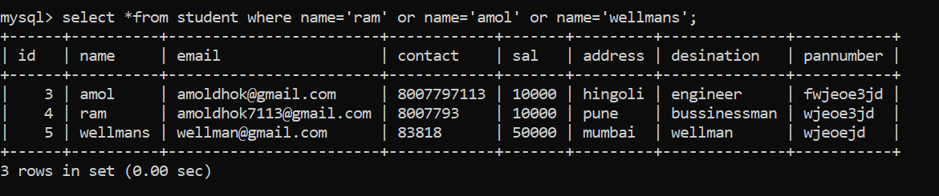

**Q16. Write SQL Query to display employee records salary wise in descending order?**

**Ans:** 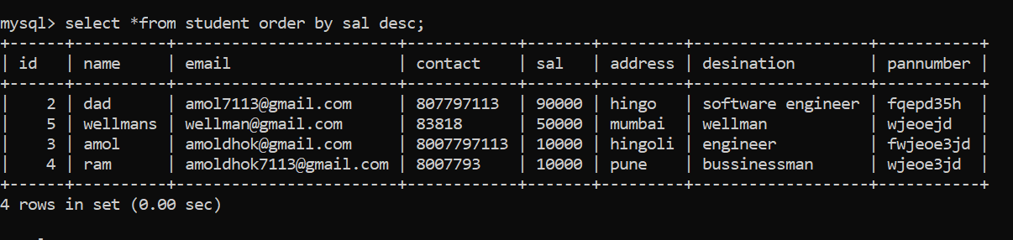

**Q17. Write SQL Query to display employee id wise in ascending order whose salary is greater than 10000?**

**Ans:**

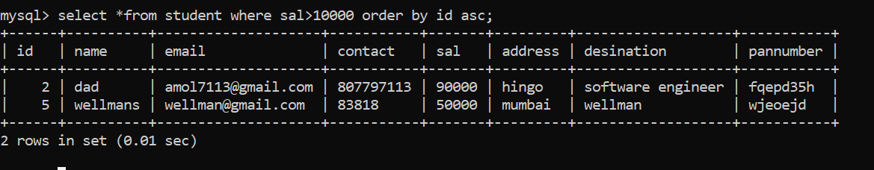

**Q18. Write SQL Query to display employee id wise in descending order whose salary is 10000, 20000, and 30000?**

**Ans:** 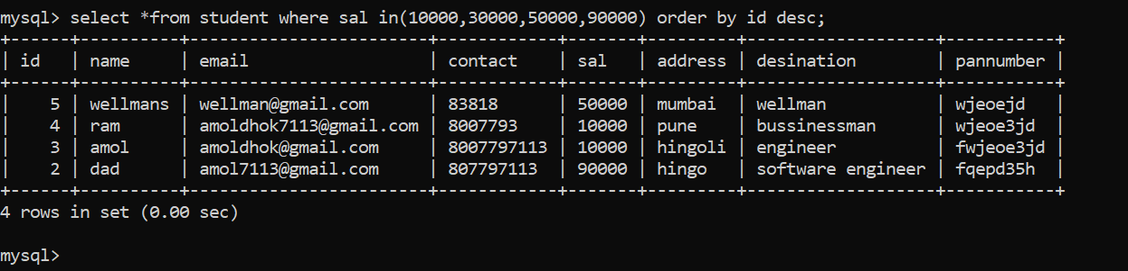

**Q19. Write SQL Query to display employee in ascending order by its name and whose salary between 100000 to 60000?**

**Ans:** 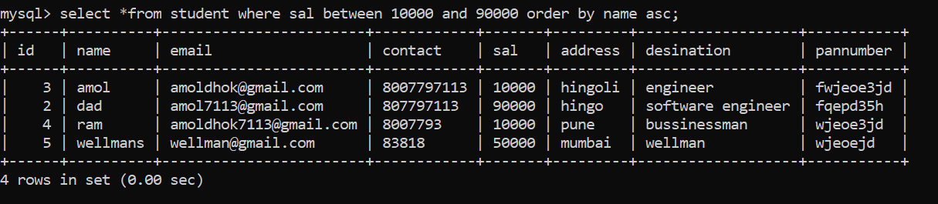

**Q20. Write SQL Query display employee name whose salary is duplicated?**

**Ans:**

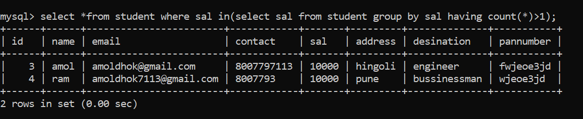

**Q1. what is diff between mysql database and SQL?**

**Ans:**

|  |  |
| --- | --- |
| **MYSQL database** | **SQL** |
| **MYSQL is database which is use to work with relational database management concepts.** | **Sql stand for structural query language it is use for work relational database management system.** |
| **MYSQL create table database view inex** |  |

**Q2. explain types of database?**

**Ans:**

**1.hierachical database: hierarchical database means we can manage data in the form of parent and child format or in tree format.**

**Ex. Window file system.**

**2.object oriented database: object oriented database means we can manage data in the form of object. Means every record has unique object in database.**

**Ex. Mango DB**

**3.distrubuted database: distributed database means we can manage one centralize server and connect that server to number of remote database.**

**Ex amazon apache ignite.**

**4.file system database: means we can store data in the form of file format and organize it.**

**Ex.MS-exel**

**5.relational database: relational database management system means we can store data in the form of row and column.**

**Ex. Mysql , oracle,db2.**

**Q3. what is DDL and DML commands and explain in details?**

**Ans: DDL stand for data definition language which is use for create table , alter table, drop table, truncate table.**

**Types of DDL command**

**1.Create : create command is use for create table , data base,view.**

**2.alter : alter commad is use for modify column, datatype, drop column, rename column**

**In alter command there are five types of contents.**

**Add : add option is use for add column in database**

**Update: update option is use for update columname**

**Modify: modify option is use for modify data type of column**

**Drop: delete option is use for delete table.**

**Rename: rename option is use for rename the column.**

**3. Drop : drop command is use for drop table**

**4.truncate : truncate is same like as drop**

**5.desc: desc command is use for show table column.**

**DML: dml stand for data manipulation language which is use for**

**Insert: there are two way to insert into table**

**Insert all column in table.**

**Insert into table name values(‘’,’’,’’,’’);**

**Insert specific column in table.**

**Insert into table name(columnname, columnname)values(value1,value2);**

**delete, update,**

**select: there are two way we can select query.**

1. **Wild card select: wild card select means select all data from database table.**
2. **Partial select: partial select means fetch particular column from database table.**

**Q4 what is constraints and why use constraints?**

**Ans: constrain are some rule and regulation we applied on database table. Constrains are use for to avoid duplicate data, null data, or verify data before inserting in database.**

**Q5. explain types of constraints**

**Ans:**

**There are six type of constrain in sql**

**Not null: not null constrain is use for to avoid not null column.**

**Unique: unique constraint is use for avoid common data.**

**Primary: primary key is by default not null and unique we cant set primary key is empty and duplicate value in primary key.**

**Foreign key: foreign key constrain is use for provide relationship between two table.**

**Default constraints: default constraint is use for to set default value.**

**Check constraints: check constraints is use for check data before inserting in database.**

**Q6. what primary key and foreign key and its differences.**

**Ans:**

|  |  |
| --- | --- |
| **primary key :** | **Foreign key:** |
| **every table only one primary key** | **More than one foreign key in single table** |
| **primary key cant be null** | **Foreign key accept null value** |
| **primary key work as reference in another table** | **Foreign key provide relation sheep between two table** |
| **primary key use cluster indexing.** | **Foreign key not use cluster indexing** |

**Q7. what is diff between unique and primary key**

**Ans:**

|  |  |
| --- | --- |
| **Unique key** | **Primary key** |
| **Single table has more than one unique key** | **single table has only one primary key** |
| **We can change unique key value** | **We cant change primary key value** |
| **Unique key may be null** | **Primary key cant be null** |
| **Unique key not use cluster indexing** | **Primary key use cluster indexing** |

**Q8. what is diff betweeen unique key and foreign key**

**Ans:**

|  |  |
| --- | --- |
| **Unique key** | **Foreign key** |
| **Single table only one unique key** | **Single table more than one foreign key** |
| **Unique key not use cluster indexing** | **Foreign key also not use cluster indexing** |
|  |  |

**Q9. what is candidate key**

**Ans: minimal set of attribute that can uniquely identify a row called as candidate key.**

**Ex. Sid int student table.**

**Q10 what is composite primary key**

**Ans:**

**Q11 what is joins and explain types of join with example?**

**Ans: join is use for fetch data from multiple table and interconnect with each other internally.**

**When we use join then we need to manage common column between two table.**

**For connect two table with each other normally we use primary key and foreign key.**

**There are five types of join**

1. **Inner join: fetch common data from left hand side and common data from right hand side called as inner join.**
2. **Outer join: outer join means fetch all record from right hand side and fetch all record from left hand side.**
3. **Left join: left join means fetch all record from left hand side and common record from right hand side.**
4. **Right join: fetch all record from right hand side and common record from left hand side called right join.**
5. **Self join: write join with same table called as self join.**

**Q12. what is normalization and explain its type**

**Ans: normalization Is technique where we can decompose the large table into smaller table for avoid redundancy of data or avoid duplicate data.**

**Q13 what happen if we design database without normalization**

**Ans: if we design database without normalization then there will be occur confusion and data inconsistency.**